**NATIONAL INSTITUTE OF TECHNOLOGY SILCHAR**

**Cachar, Assam**

**B.Tech. IVth Sem**

**Subject Code:** CS215

**Subject Name:** Signals and Data Communication

**Submitted By:**

Name : Subhojit Ghimire

Sch. Id. : 1912160

Branch : CSE – B

1. **A system with frequency response,**

$$H \left(e^{jω}\right)= \frac{e^{jω}}{e^{jω}-0.7}$$

**The system is excited by $x\left[n\right]=tri \left(\frac{n-8}{8}\right)$. Use DTFT to find the system response y[n] through MATLAB. Plot excitation, Impulse response and System response. Use 123 sample points. The “tri” function is defined as,**

$$tri \left(n\right)= \left\{\begin{aligned}1-\left|n\right| ,\left|n\right|<1 \\ 0 ,otherwise\end{aligned}\right.$$

* **AIM: TO PLOT EXCITATION, IMPULSE RESPONSE AND SYSTEM RESPONSE FOR A PROVIDED SYSTEM USING 123 SAMPLE POINTS.**

**THEORITICAL BACKGROUND:**

1. **Impulse Response:** The impulse response of a dynamic system is its output when presented with a brief input signal, called an impulse.
2. **Frequency Response:** The frequency response is the relationship between the system input and the output in the Fourier Domain.
3. **Discrete Time Fourier Signal:** It converts the discrete time signal x[n] into a function X(ejω) of the discrete frequency ω(rad).

**METHODOLOGY:  
1.** The DTFT is calculated using diric() function.  
**2.** The system response is obtained using ifft() function.  
**3.** The tri signal is obtained using tripuls() function.

**CODE:**

clear all;  
clc;  
  
N = 128;

k = 0:N-1;

n = k;

x = triangularPulse ((n-8)/8);

X = fft (x);

H = exp (1i*2*pi*k/N) ./ (exp(1i*2*pi*k/N)-0.7);

h = real (ifft(H));

Y = H .* X;

y = real (ifft(Y));

subplot (3, 1, 1);

excitPlt = stem (n, x, 'k', 'filled');

grid on;

pbaspect ([2 1 1]);

axis ([0, 30, 0, 1]);

xlabel ('\itn');

ylabel ('x[{\itn}]');

title ('Excitation');

subplot (3, 1, 2);

impulsePlt = stem (n, h, 'k', 'filled');

grid on;

pbaspect ([2 1 1]);

axis ([0, 30, 0, 1]);

xlabel ('\itn');

ylabel ('h[{\itn}]');

title ('Impulse Response');

subplot (3, 1, 3);

respPle = stem (n, y, 'k', 'filled');

grid on;

pbaspect ([2 1 1]);

axis ([0, 30, 0, 3]);

xlabel ('\itn');

ylabel ('y[{\itn}]');

title ('System Response');

**INPUT DATA DESCRIPTION:**

The number of samples taken is N = 128.

Only the first 30 samples have been plotted.

**RESULT:**

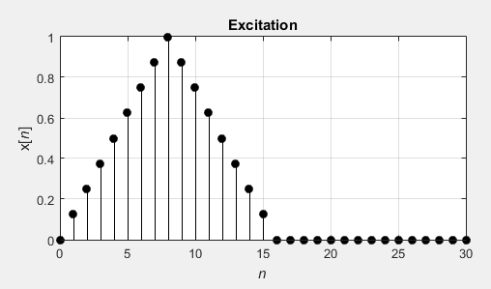

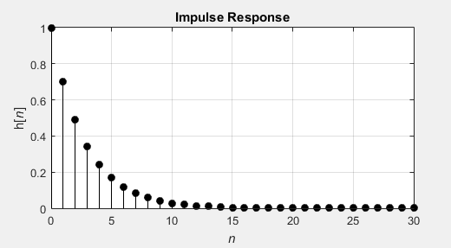

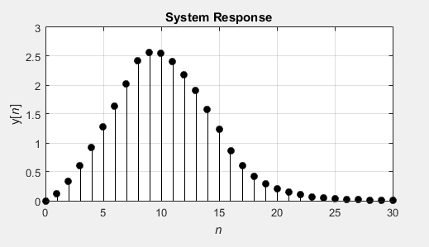

**CONCLUSION/DISCUSSION:**

In the frequency domain, the system response (convolution) is

$$Y\left(e^{jω}\right)=H \left(e^{jω}\right)∙X(e^{jω})$$ The time domain counterpart can be found by applying the discrete-time inverse Fourier transform.

Hence, the convolution is performed in the frequency domain by multiplying the discrete-time Fourier transforms of the excitation and the impulse response.